**DAILY ONLINE ACTIVITIES SUMMARY**

|  |  |  |  |  |  |  |  |  |
| --- | --- | --- | --- | --- | --- | --- | --- | --- |
| **Date:** | **05-06-2020** | | | | | **Name:** | **Kanaka BS** | |
| **Sem & Sec** | **6th - A** | | | | | **USN:** | **4AL17CS039** | |
| **Online Test Summary** | | | | | | | | |
| **Subject** | | **OR-III**  **PAP-II(assignment)** | | | | | | |
| **Max. Marks** | | **30**  **20** | | **Score** | | | **30(OR)**  **15(PAP)** | |
| **Certification Course Summary** | | | | | | | | |
| **Course** | **Complete Python Developer in 2020** | | | | | | | |
| **Certificate Provider** | | | **Udemy** | | **Duration** | | | **30 hours** |
| **Coding Challenges** | | | | | | | | |
| **Problem Statemen:**  1. **Java program to implement Circular Linked List Using Array And Class**  **2.** **Python program to square each odd number in the list**  **3.** **The program takes a string and removes the nth index character from the non-empty string.** | | | | | | | | |
| **Status: executed** | | | | | | | | |
| **Uploaded the report in Github** | | | | | **yes** | | | |
| **If yes Repository name** | | | | | <https://github.com/kanakabs/Daily-Status/tree/master/05-06-20/online%20coding> | | | |
| **Uploaded the report in slack** | | | | | **Yes** | | | |

CERTIFICATION COURSE DETAILS

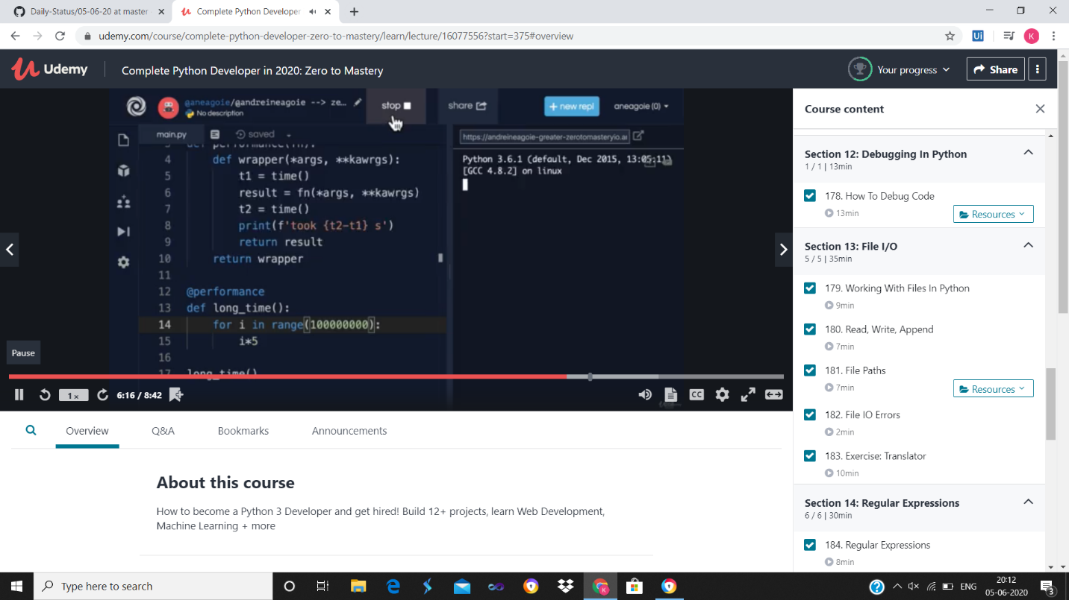

ONLINE TEST DETAILS

PAP

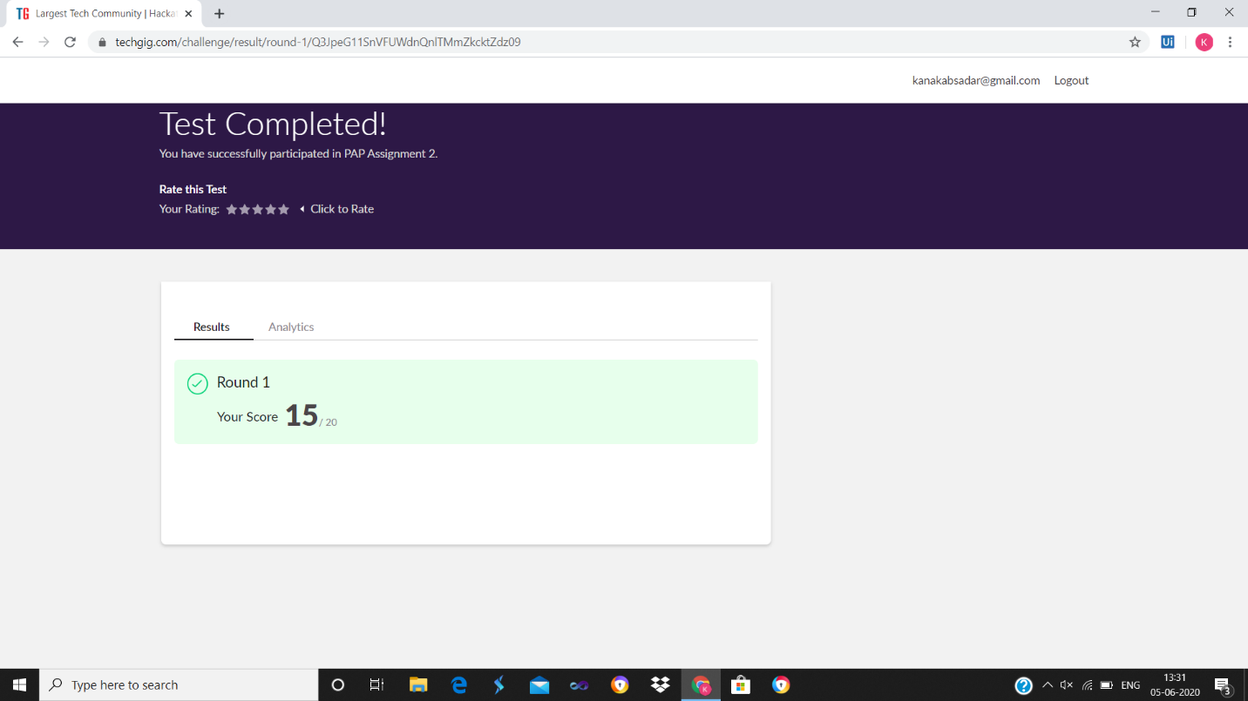

OR

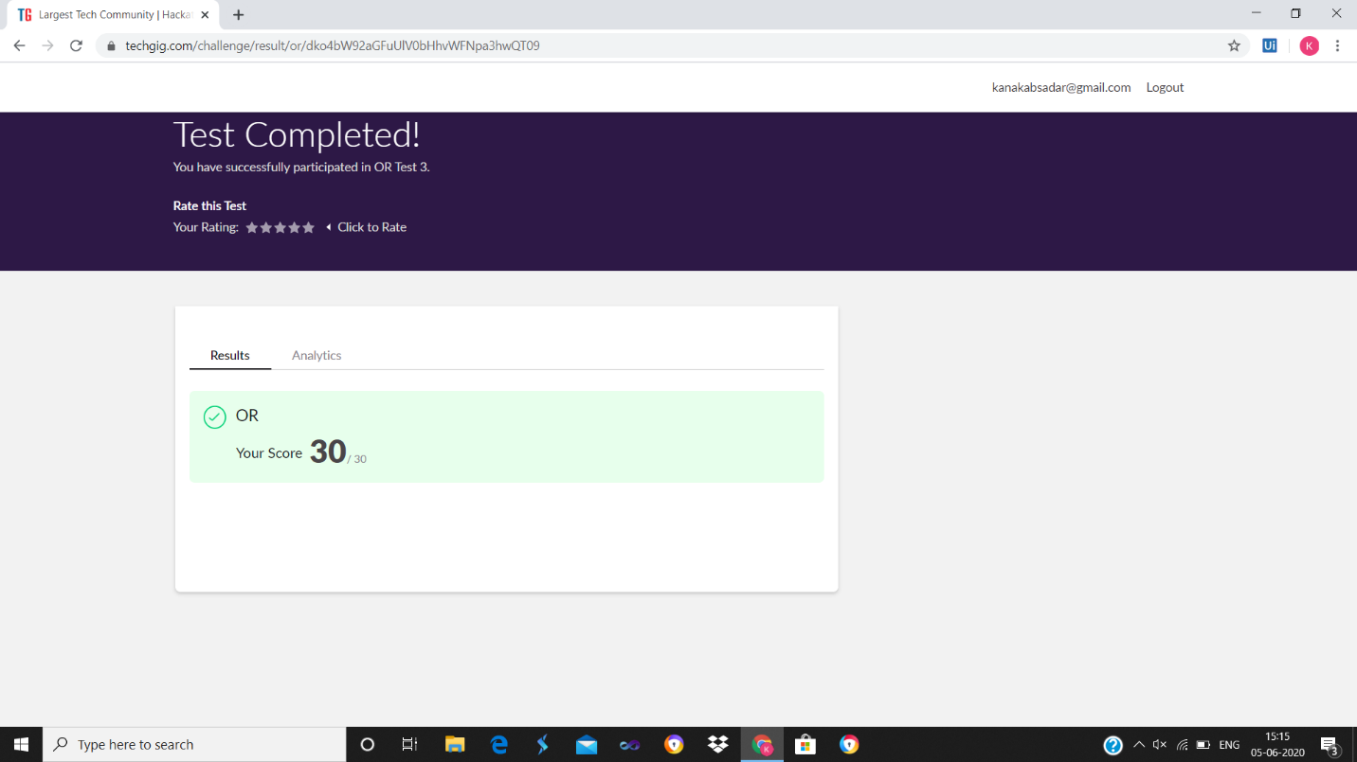

ONLINE PROGRAMING

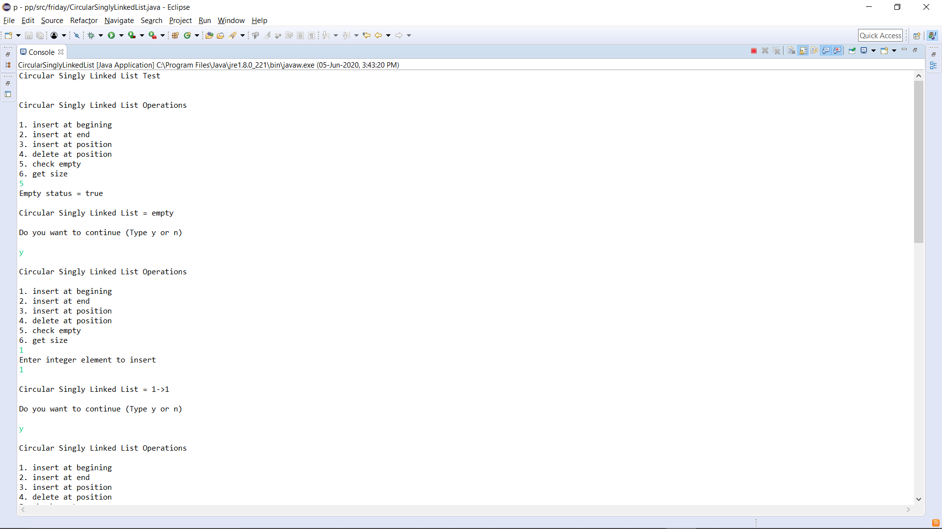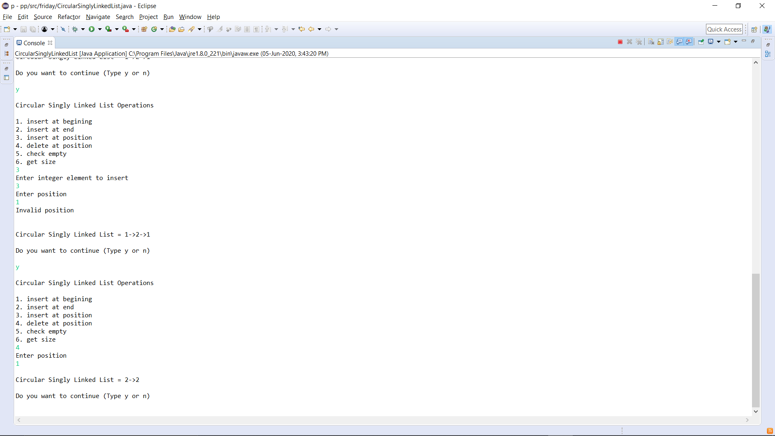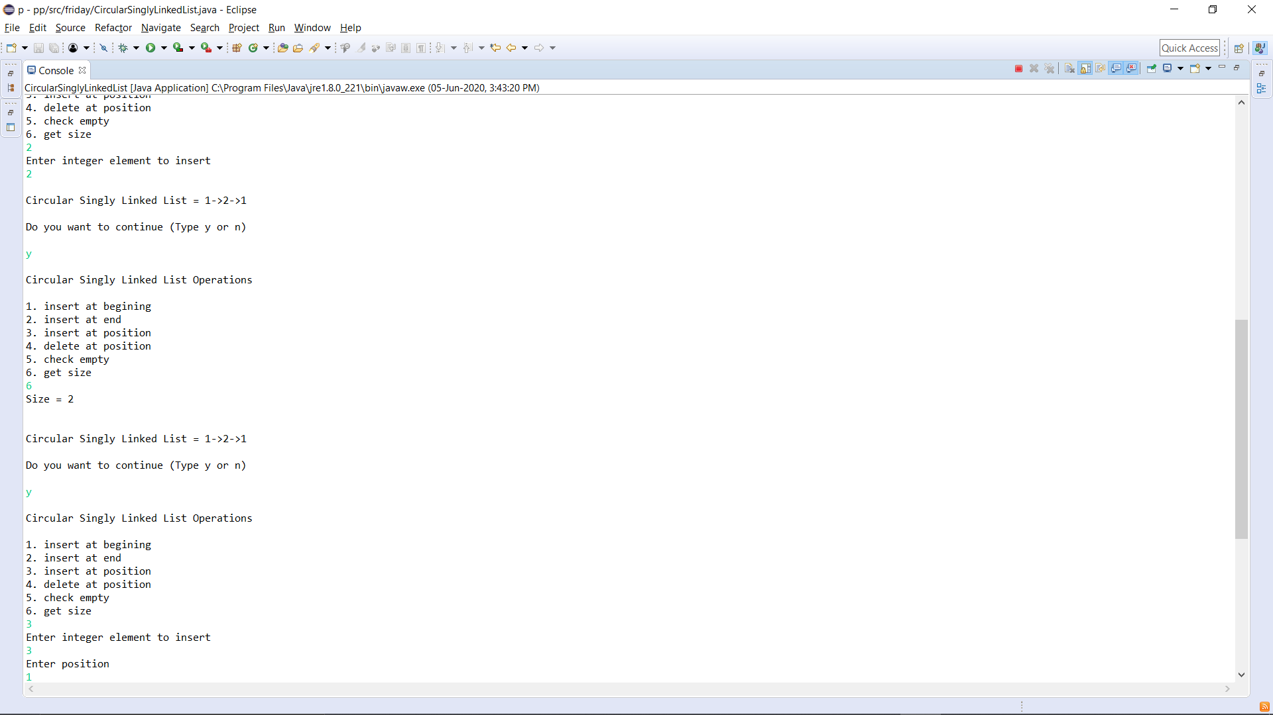p-1

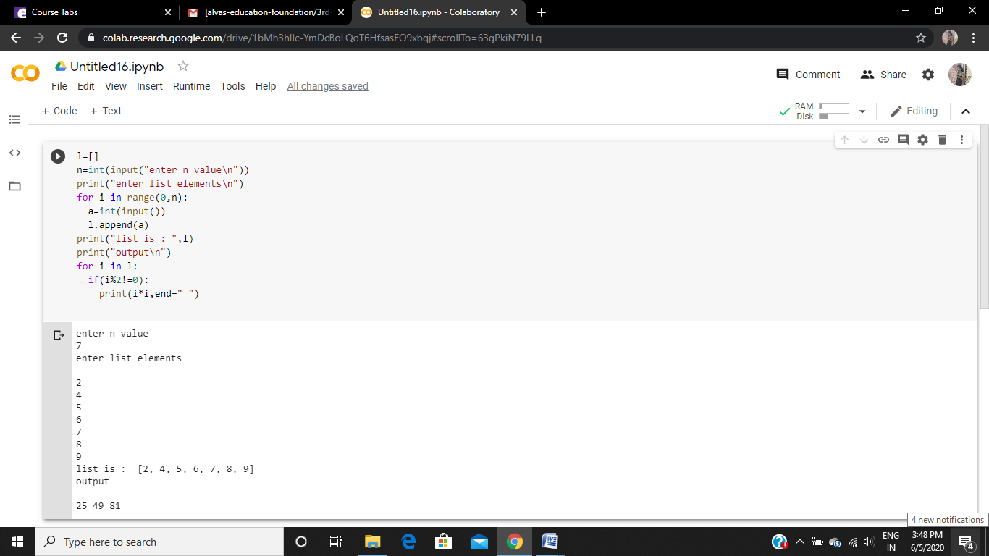P-2

P3

